In order to open these files. You must have Python.

Jupyter notebook in Anaconda or Python in Vscode, Though jupyter notebook is more preferable for beginners and is what we will be using throughout this course.

Once you have anaconda downloaded ( https://www.anaconda.com/download ==> Press the "skip button under the big green "Submit" button ) and installed in your system, You can now get started.

Search in windows search bar "Jupyter Notebook" and you will be directed to a page like this.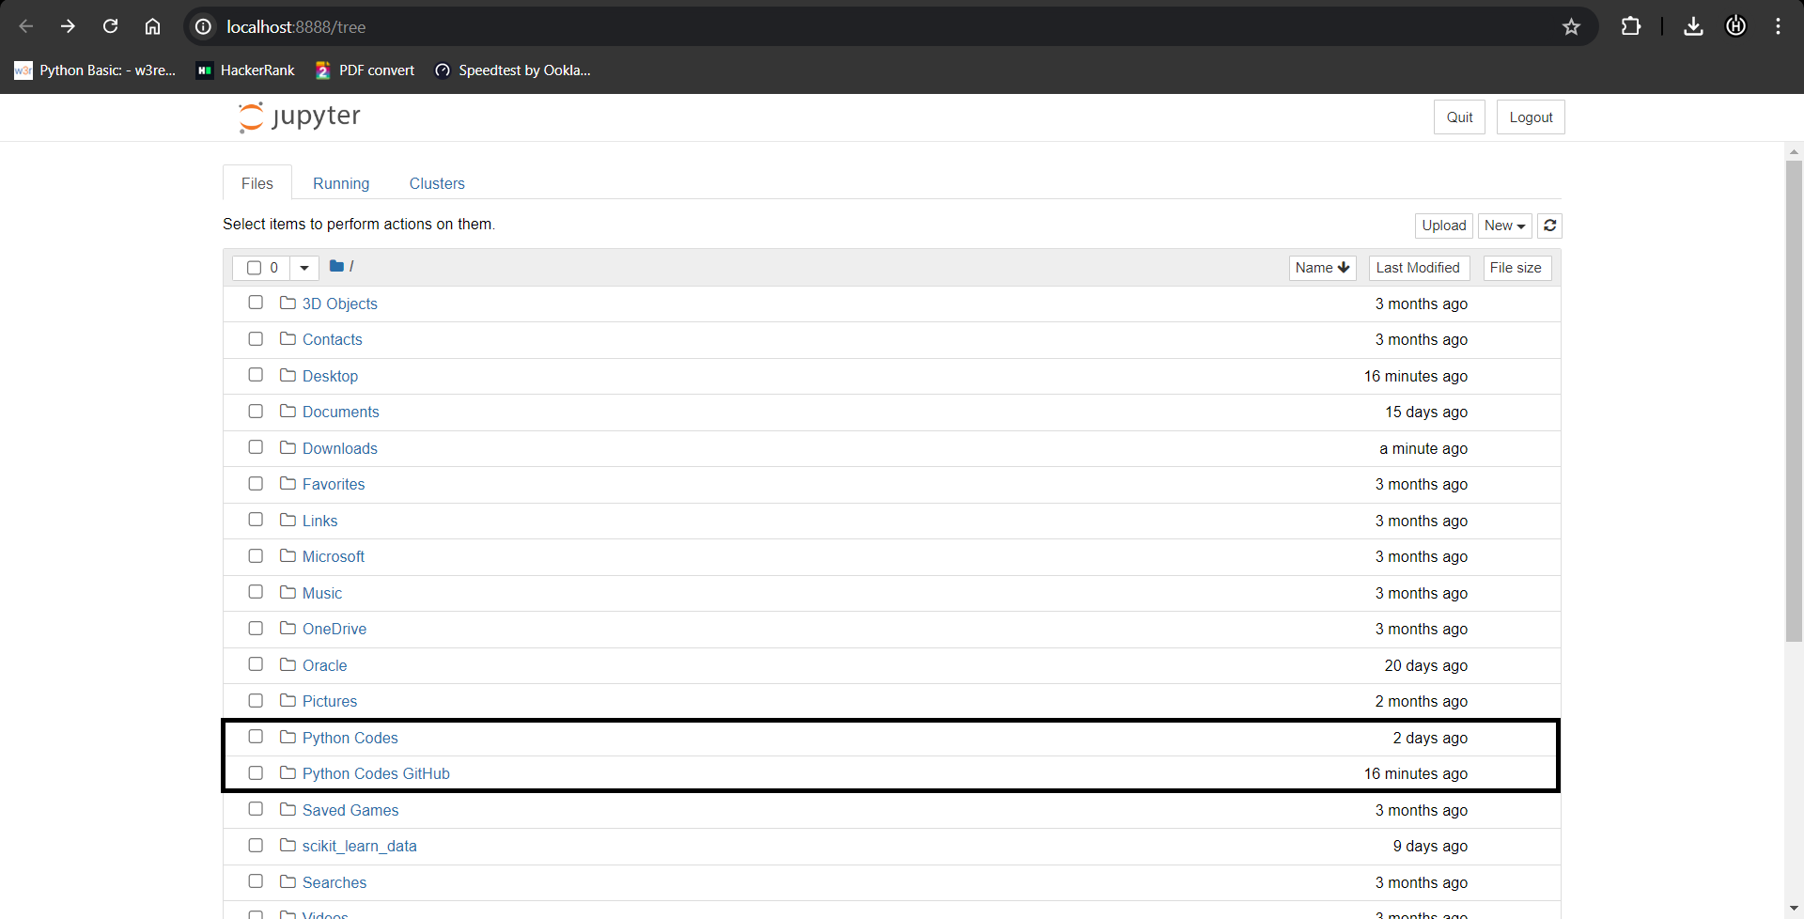

It is advisable to make a new folder here for your python codes as highlighted in the above picture. You can do that by pressing the button on the top right corner “New”.

All these files are on your local computer, You User files. (C:\Users\Your user name). And it is also advisable to clone your repository to your user folder as it will be easier to navigate to your repository.

You also use that same button to make a new notebook (Python 3) as shown in the pic above.

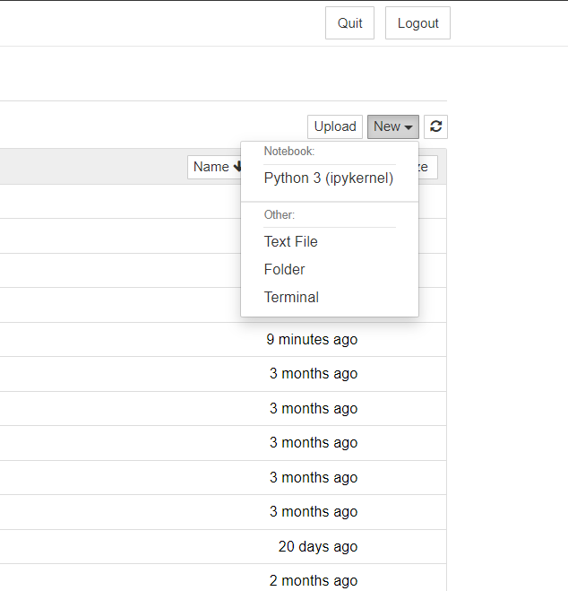

To open an already existing book or if you download it from the internet, you simply navigate to where your files are stored and click on them through this browser interface and the file should open in a new tab automatically.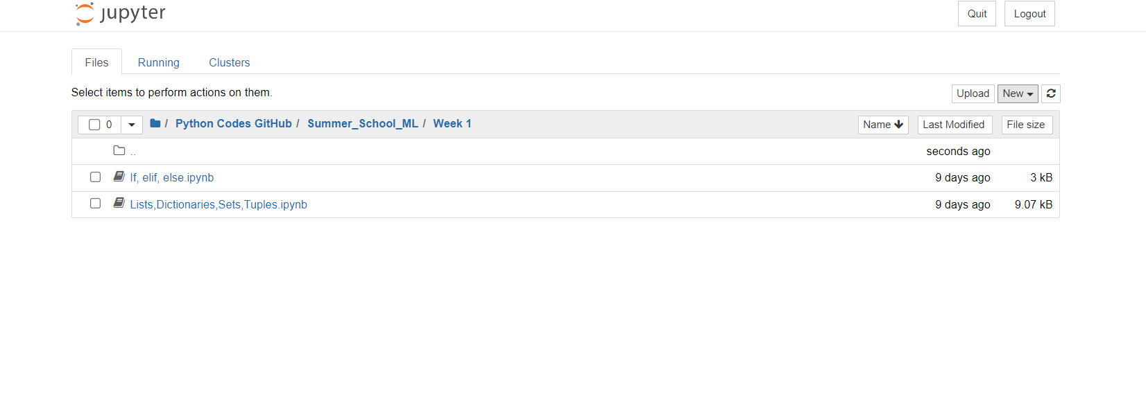

**A few simple commands**

To run a cell have the cell selected and press : Shift + Enter or CTRL + Enter.

To open a new cell, select an already existing cell so that it’s outline color is blue(by pressing outside the text area of the cell) and press “A” or “B”

To Delete a cell press D+D

To save your code press CTRL + S

